TEAM 5 PROJECT
Equipment Needed
- Essential physical equipment
- Real-time PCR/qPCR machine
- 96-well optical PCR plate
- Plate block/sample block
- Plate adapter/support, if required by the selected instrument
- Optical adhesive sealing film or optical caps
- PCR machine touchscreen/display
- Machine drawer/chamber
- Plate orientation/A1 marker
- Plate barcode/sample identification
- Laboratory/environment assets
- Laboratory bench
- Laboratory gloves
- Laboratory coat
- Appropriate laboratory environment/background
- Waste/biohazard container if visible in the scene
- Scientific visualization assets
- Double-stranded DNA
- Separated DNA strands
- Primers
- DNA polymerase
- Newly synthesized DNA
- Fluorescence/amplification visualization

Procedures Involved
Step 1: Receive the prepared 96-well PCR plate
- Plate comes from Team 4.
- Verify plate orientation/identification and sealing.
Step 2: Load the plate into the real-time PCR machine
- Open machine drawer/chamber.
- Position the plate correctly.
- Close the chamber.
Step 3: Program the PCR run
- Denaturation: 95°C
- Annealing: 60°C
- Extension: 72°C
- 35 cycles
- Real-time fluorescence monitoring.
Step 4: Run and visualize PCR amplification
- Show DNA strands separating.
- Show primers and DNA polymerase.
- Show newly synthesized DNA.
- Repeat the amplification cycle.
Step 5: Visualize fluorescence/amplification
- Fluorescence increases as amplification occurs.
- Display the amplification curve/readout.
Step 6: Complete the PCR run
- Show completion after the programmed cycles.
- Transition to the results screen.
Parameters Needed
Parameter | Value
Denaturation | 95°C
Annealing | 60°C
Extension | 72°C
Number of cycles | 35
Readout | Real-time fluorescence
Run duration shown in deck | ~2 hours

Scientific Storyboard
Loading → Programming → Running → Amplification → Results
Objective:
The learner should understand what happens when a prepared PCR plate enters a real-time PCR machine and how amplification is monitored.

SCENE 1 — RECEIVE THE PREPARED PLATE
What happens:
Team 5 receives the prepared 96-well optical PCR plate from Team 4.
Visuals:
- 96-well PCR plate
- Optical sealing film/caps
- Plate orientation/A1 marker
- Sample/plate identification

Scientist explanation:
The PCR plate has already been prepared with the master mix, samples, and controls. Team 5 now loads the prepared plate into the real-time PCR machine.

SCENE 2 — LOAD THE PCR MACHINE
Interaction
The user should be able to:
OPEN → PLACE PLATE → CHECK ORIENTATION → CLOSE
Visuals:
- Real-time PCR/qPCR machine
- Machine drawer/chamber
- Plate block/sample block
- Plate adapter/support if applicable
- 96-well plate

Scientist explanation:
The prepared plate is positioned correctly inside the PCR machine. Proper orientation ensures that the wells correspond correctly to the programmed plate layout.

Your document specifically identifies the plate block, plate adapter/support, machine drawer/chamber, and A1 orientation marker as Team 5 assets.

SCENE 3 — PROGRAM THE MACHINE
On-screen machine interface
Show something like:
Step | Temperature | Purpose
Denaturation | 95°C | DNA strands separate
Annealing | 60°C | Primers bind
Extension | 72°C | DNA is synthesized

Cycles: 35 (Repeat the process)

Interaction
The learner could interact with:
PCR RUN → SET TEMPERATURES → SET 35 CYCLES → START
Scientist explanation:
The PCR machine is programmed to repeatedly perform denaturation, annealing, and extension for 35 cycles while monitoring fluorescence in real time.

SCENE 4 — START THE RUN
The learner presses:

- START RUN
The machine changes to:
- RUNNING
Then show:
Cycle 1 / 35
The thermal cycle begins.

SCENE 5 — DENATURATION
95°C
Visual animation:
Double-stranded DNA
→ heat applied
→ two strands separate.

The equipment specifically lists: Double-stranded DNA, Separated DNA strands as scientific visualization assets.

Explanation : During denaturation, the double-stranded DNA separates into single strands.

SCENE 6 — ANNEALING
60°C

Show:
- Separated DNA strands + primers
- The primers attach to their complementary target sequences.

Explanation
During annealing, primers bind to complementary sequences on the DNA template.

SCENE 7 — EXTENSION
72°C
Show:
- DNA polymerase → newly synthesized DNA
- The polymerase extends from the primers and produces new DNA strands.
Explanation
“During extension, DNA polymerase synthesizes new DNA using the template strand.”

The equipment session specifically lists DNA polymerase and newly synthesized DNA as visual assets.

SCENE 8 — REPEAT THE CYCLE
Now visually communicate:
95°C → 60°C → 72°C
Cycle 1 → Cycle 2 → Cycle 3 → … → Cycle 35
You don’t necessarily need to make the user watch all 35 cycles in real time. You could accelerate the visualization while maintaining the cycle counter.
For example:
Cycle 01/35
Cycle 05/35
Cycle 10/35
Cycle 20/35
Cycle 30/35
Cycle 35/35

SCENE 9 — REAL-TIME FLUORESCENCE
While amplification occurs, show fluorescence/amplification visualization.
Conceptually:
- More amplified target → stronger fluorescence signal
- The machine monitors this signal during the PCR run.
Visual idea
Have a small graph appear beside the machine:
Y-axis: Fluorescence
X-axis: Cycle number
Initially:
Then:

______／

Then:

____／

Eventually:

___／￣￣￣￣

This develops into the amplification curve.

The graph can like the picture below
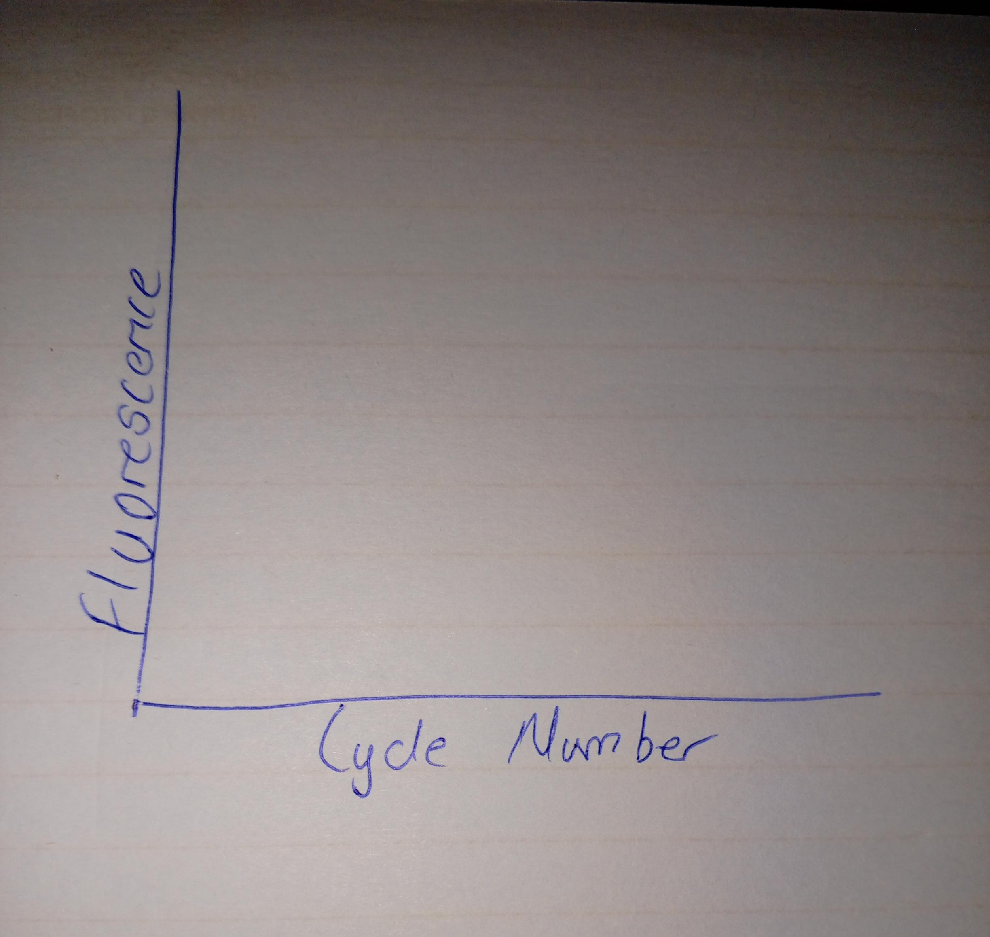

SCENE 10 — PCR COMPLETE
After cycle 35:
MACHINE SCREEN
RUN COMPLETE

Then transition from:
RUNNING → RESULTS

SCENE 11 — RESULTS SCREEN
This is the final scientific scene.
Display: REAL-TIME PCR RESULTS
- Amplification curve
- X-axis: Cycle number
- Y-axis: Fluorescence
- Threshold line
- Amplification curve
- Cq/Ct-related result information, if the project implements it
EXPLANATION
“The amplification curve shows how fluorescence changes as amplification proceeds during the PCR cycles.”

This is where the learner understands that real-time PCR is not simply heating DNA 35 times; fluorescence is monitored during amplification to generate a measurable amplification curve.

